SQL BOLT

SQL Lesson 1:

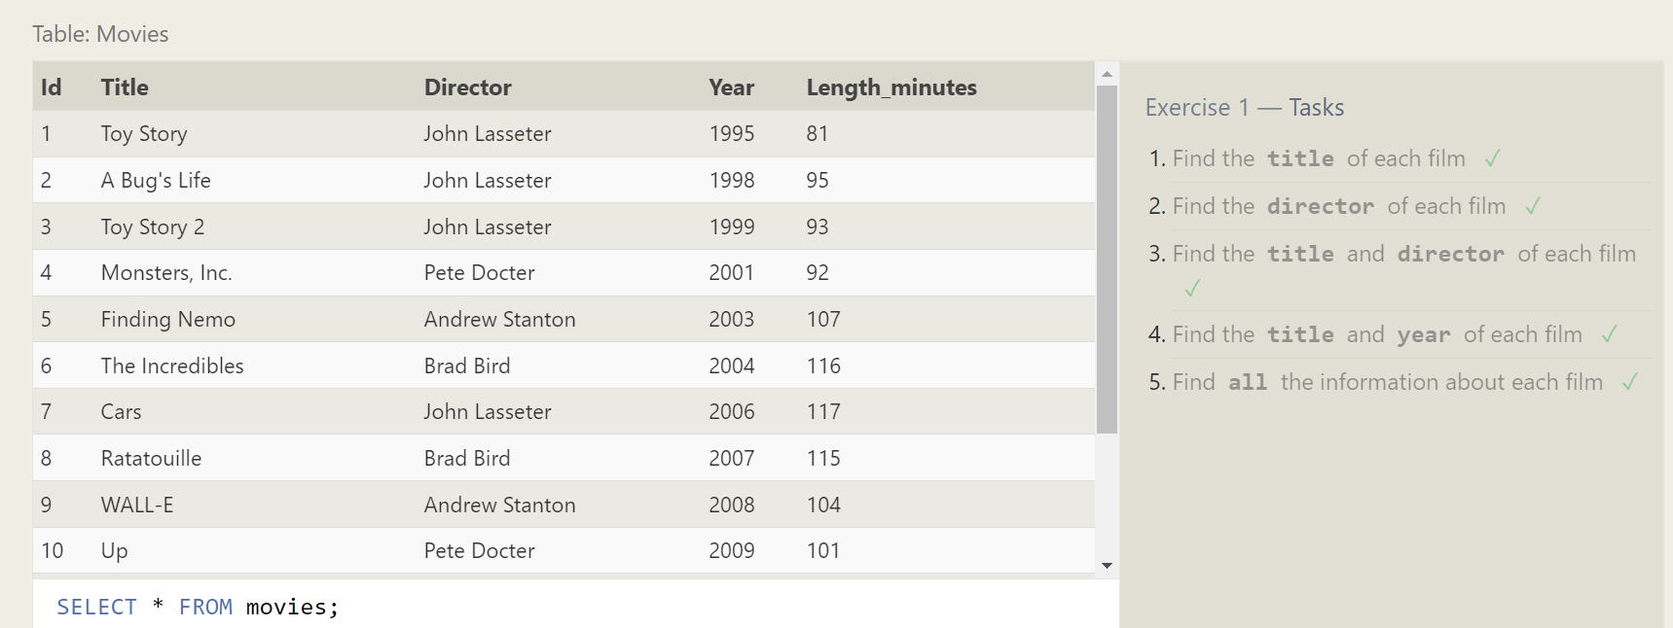

SQL Lesson 2:

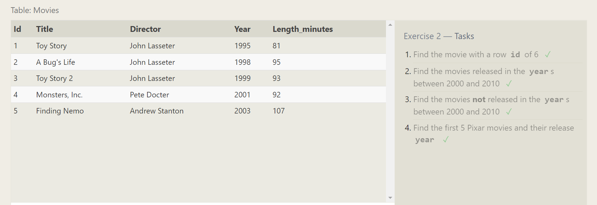

SQL Lesson 3:

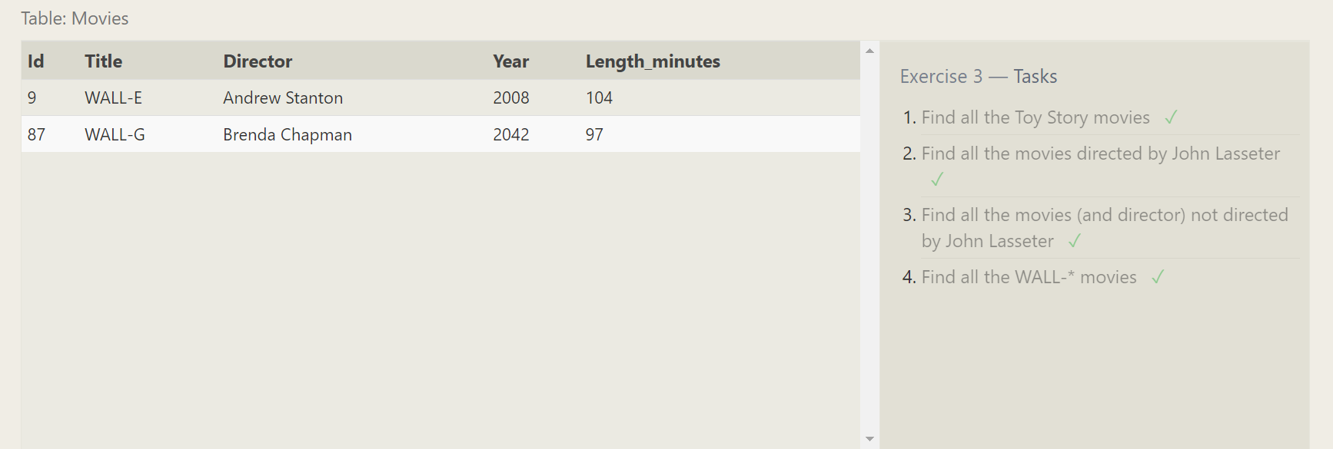

SQL Lesson 4:

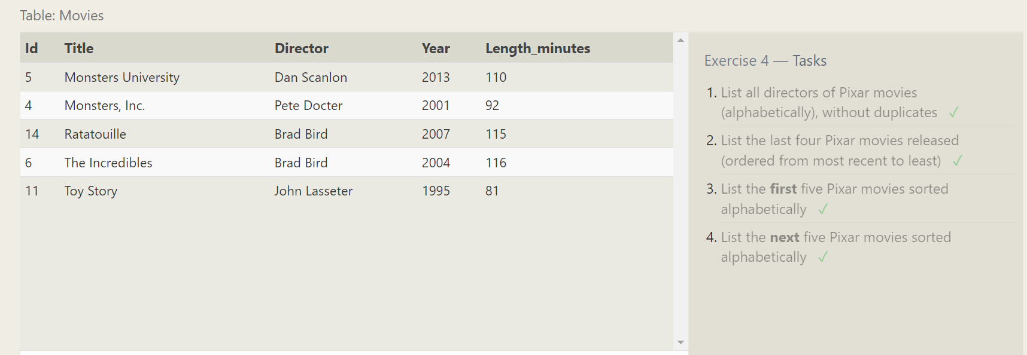

SQL Lesson 5:

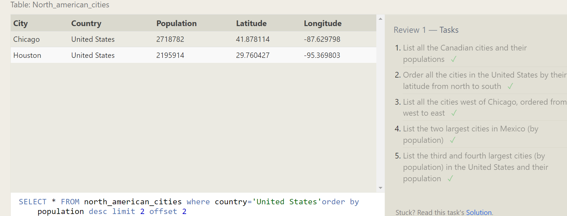

SQL Lesson 6:

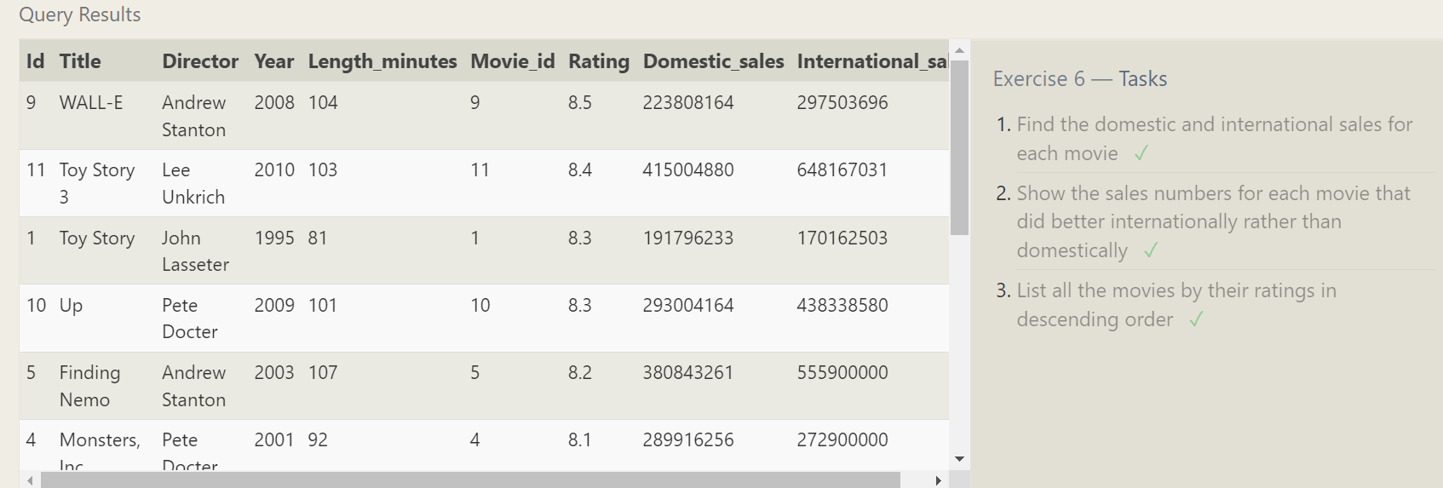

SQL Lesson 7:

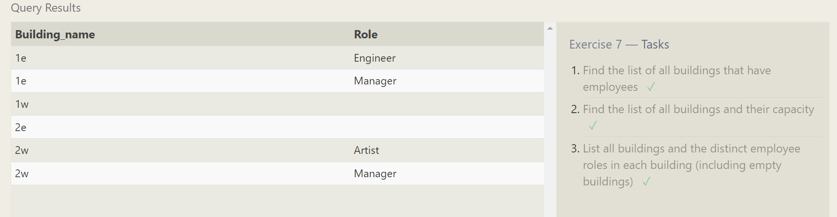

SQL Lesson 8:

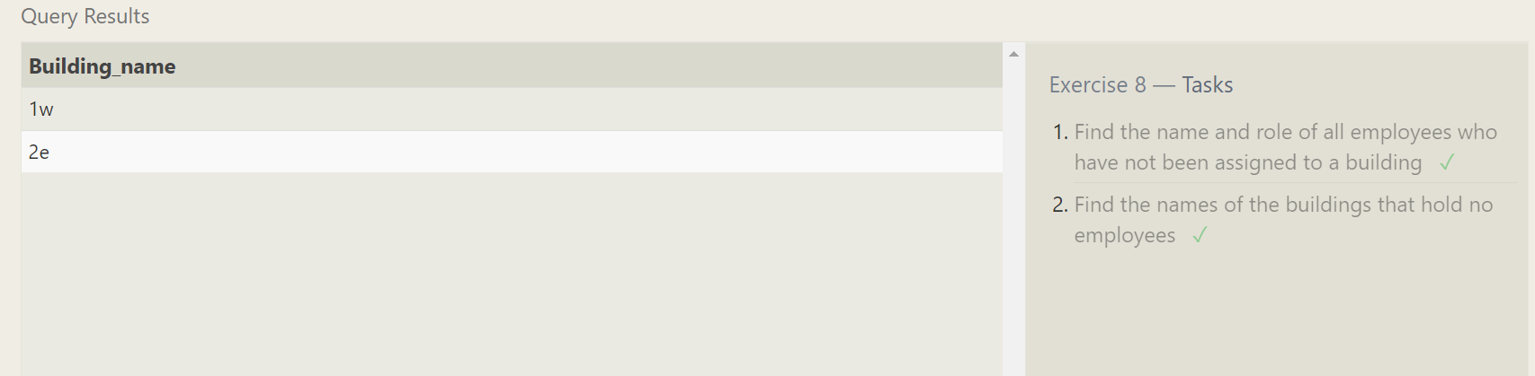

SQL Lesson 9:

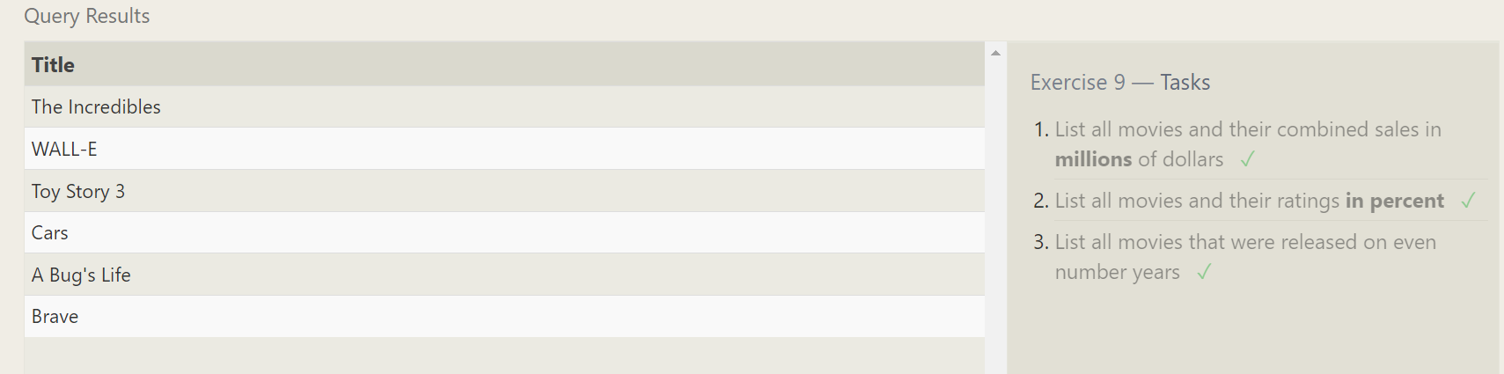

SQL Lesson 10:

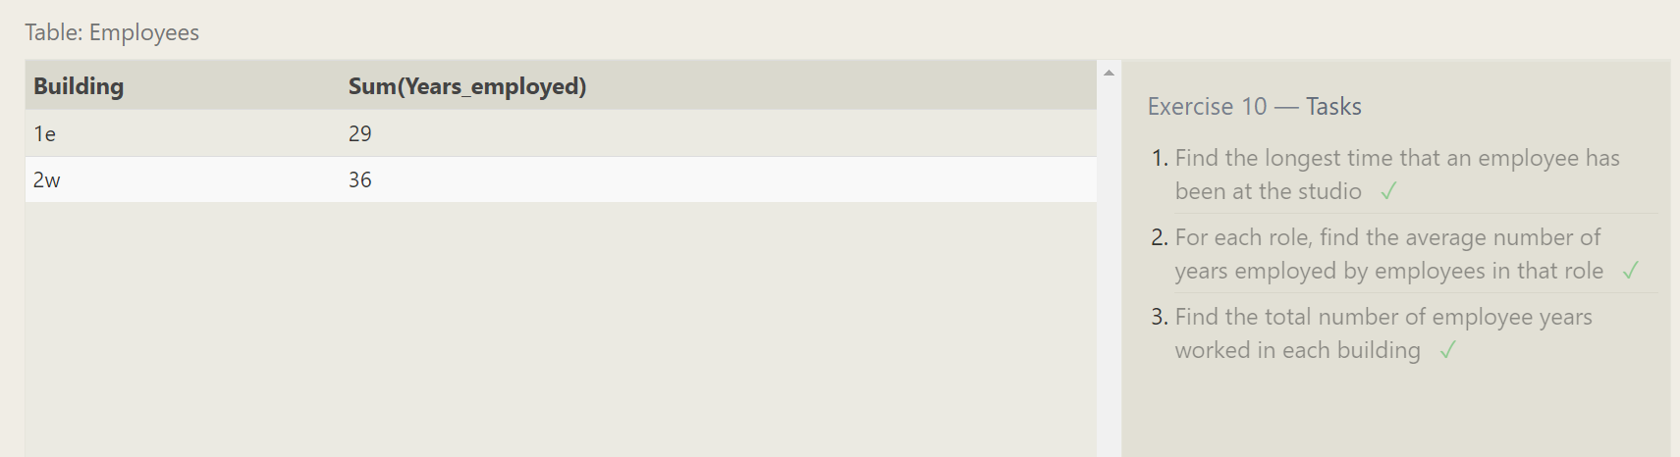

SQL Lesson 11:

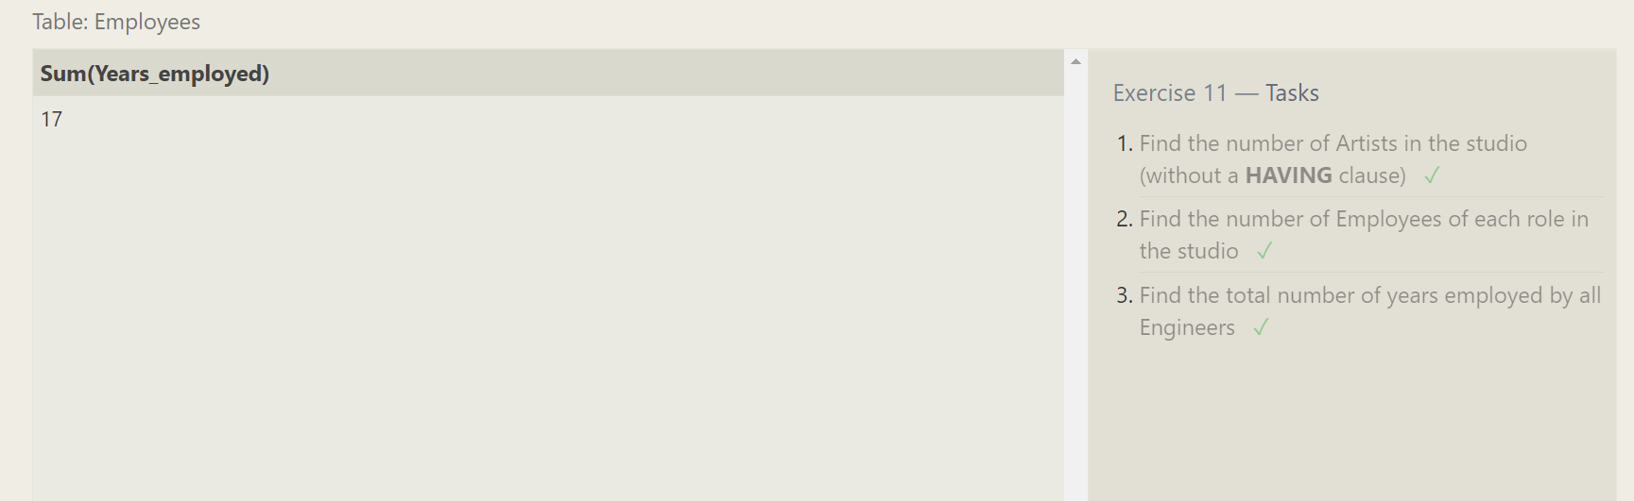

SQL Lesson 12:

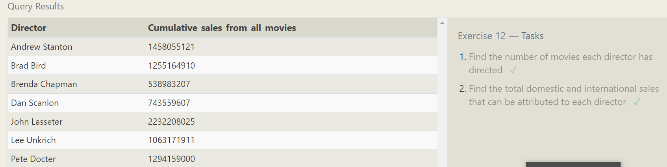

SQL Lesson 13:

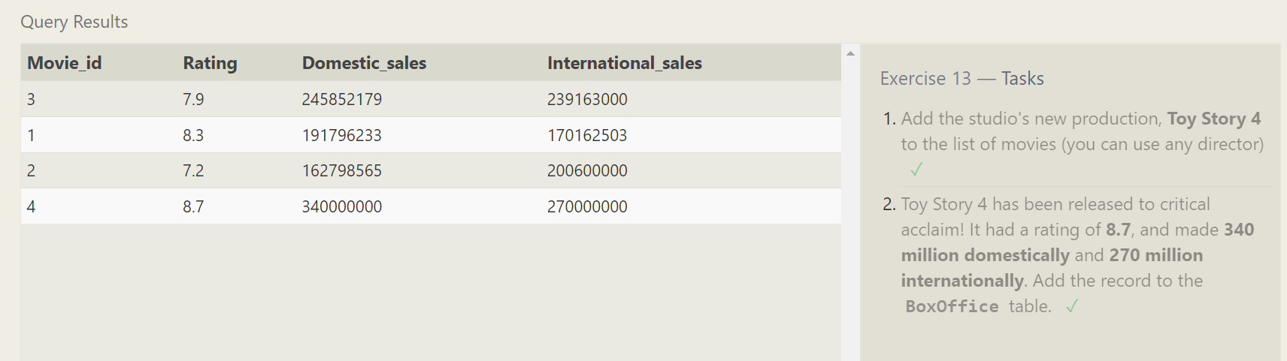

SQL Lesson 14:

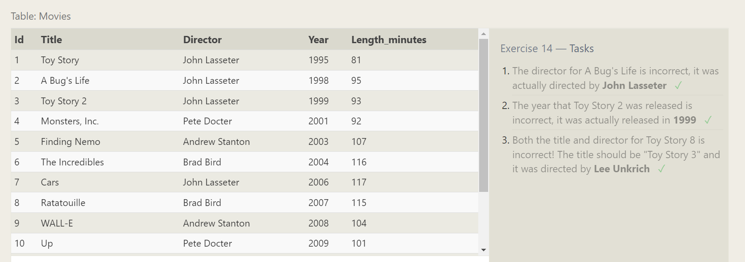

SQL Lesson 15:

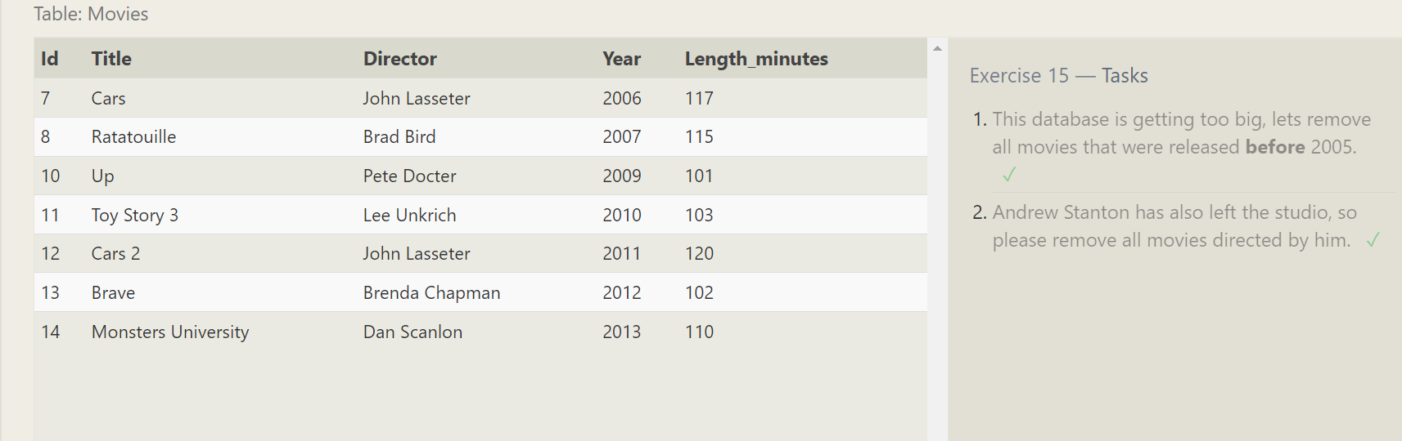

SQL Lesson 16:

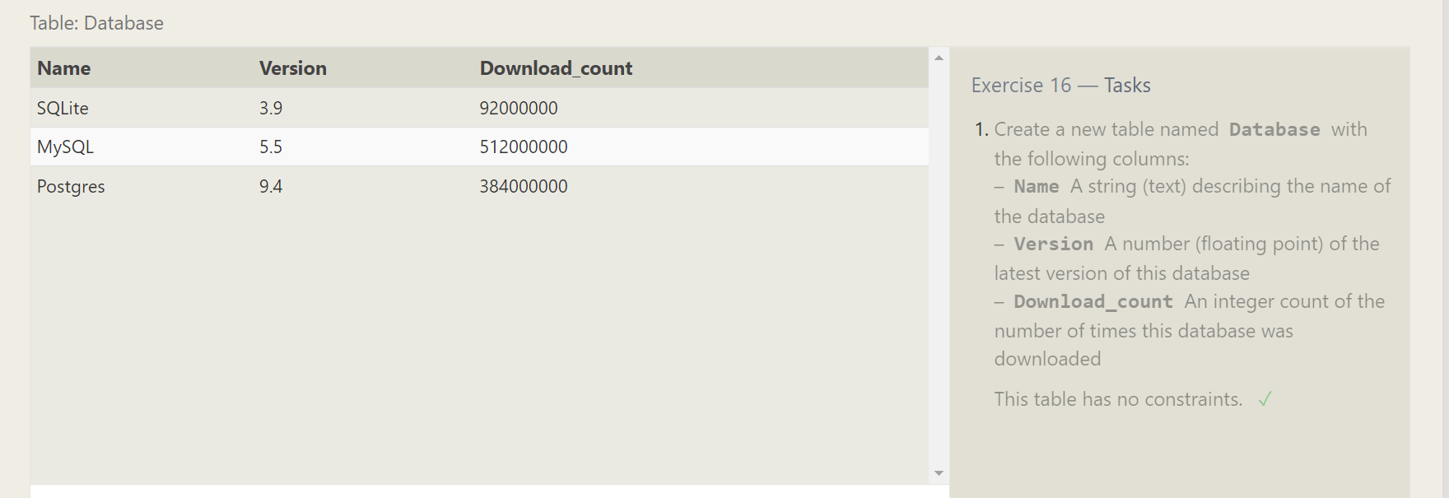

SQL Lesson 17:

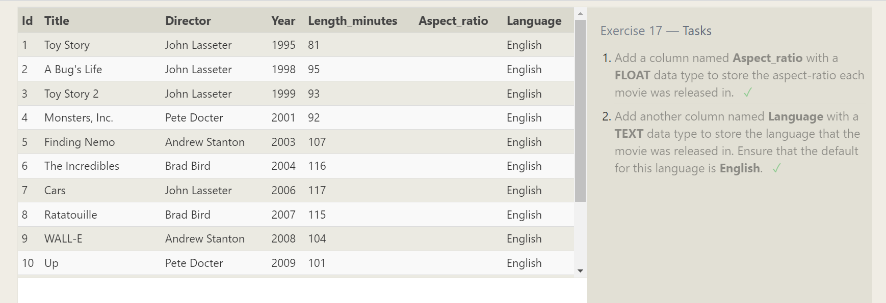

SQL Lesson 18:

